

American International University-Bangladesh (AIUB)

# Faculty of Science and Technology (FST) Department of Computer Science (CS)

**SDPM Group Project, Fall 2023 Project Title:**

# Automated Ticket Booking System for Dhaka Subway System.

**Section: A**

**Submitted by:**

|  |  |
| --- | --- |
| Name | ID |
| Dihan, MD. Rafee-uzzaman | 19-40320-1 |
| Islam Md Raduanul | 19-39903-1 |
| Naorin Sultana | 18-38538-2 |
| Imran Shikder Shobuz | 18-38756-3 |

# Table of Contents

**Title Page**

1. Introduction 3
2. Project Title 3
3. Objectives 3
4. Justification 4
5. Systems Overview 4
6. Stakeholders Analysis 5
7. Feasibility Study 5
8. Systems Component 6
9. Process Model 6
10. Efforts Estimation 7
11. Activity Diagram 8
12. Risk Analysis 9
13. Budget for the project 9
14. Conclusion 12

# Introduction:

This is a Software Development Project Management plan for Dhaka subway system automated ticket booking system. This system sells subway tickets. User can buy tickets using their valid credit cards. Users select destination and use credit card for payment. After valid transaction the ticket is issued. This software project will explain details about the software development lifecycle which our group take in order to complete. This document will cover detail information about the project. Its specifics the technical and managerial approaches to develop the software product.

# Project Title:

Automated Ticket Booking System for Dhaka Subway System.

# Objectives:

The automated ticket system is currently maintaining the project Transport Company’s process manually which is a very time-consuming process. It deals with transport industry’s ticket booking and transport maintenance, so it becomes a very tedious job for the ticket booking transporter to look after these particulars to complete the task at right time. The bus ticket booking system not only deals with transporters owned vehicles but also takes into consideration about the other types project of system transport vehicles available with other transporters. To develop a software application that supports Specific to the project Travel Agency Automation that can solve all tedious tasks related to ticket booking in a travel agency.

* This system will lead to increase in the ticket booking efficiency of the project Staff and members of the Ticket Booking Agency with little throughput.
* This system project is made as user friendly as possible so that anyone can use it with little knowledge of system computers.
* The ticket booking project will reduce the ticket booking tedious job of system paperwork by keeping all the project details of bus ticket booking, cancelling tickets are stored in the form database in computer’s hard disk.
* Up-to-date information of the system Performance status and other enquires.
* We provide up to date information that is not possible manually.
* The objective of my project is to make easy the ticket booking project system of Ticket Booking Agency simple, reliable, user friendly, and corrective. Moreover, less time consuming as compared to manual work.

# Justification:

Ticketing systems play a vital role in helping businesses. Such as how to effectively deal with high volumes of customer support requests from a variety of communication channels. However, a huge number of organizations are still ignoring this customer service tool. This is mainly due to the lack of understanding of what a ticketing system is and how it can help a business. There are benefits to using ticketing systems software. Here is the advantage of using ticketing software.

1. The platform you choose should help your team handle a higher volume of tickets per day than they could on their own. Many of the most popular systems include ticket management tools and other capabilities to improve the efficiency of your service.
2. Mobile support is a must for every enterprise help desk. The top software options allow for seamless service whether the user is on a desktop or mobile device. Some also come with mobile apps.
3. Tracking your ticketing statistics and data is essential to improving your performance. Your ticketing system should make it easy to order reports, and make improvements as needed.
4. Finally, your ticketing software should improve the quality of your service by making it more personal.

# Systems Overview:

The automated ticket booking system acts as the single point of contact between end users and the IT service provider. It helps service desk teams consolidate support requests from different channels into tickets, store them, and manage them centrally. The ticketing system also helps categorize, prioritize, and assign these tickets according to pre-set policies, ensuring that service desk teams stay efficient and organized. All conversations with the end user can also be documented within the ticketing system, helping technicians be context-aware when tickets are assigned or escalated to them. A ticketing system is also referred to as a help desk ticketing system, support ticket system, or ticket management system.

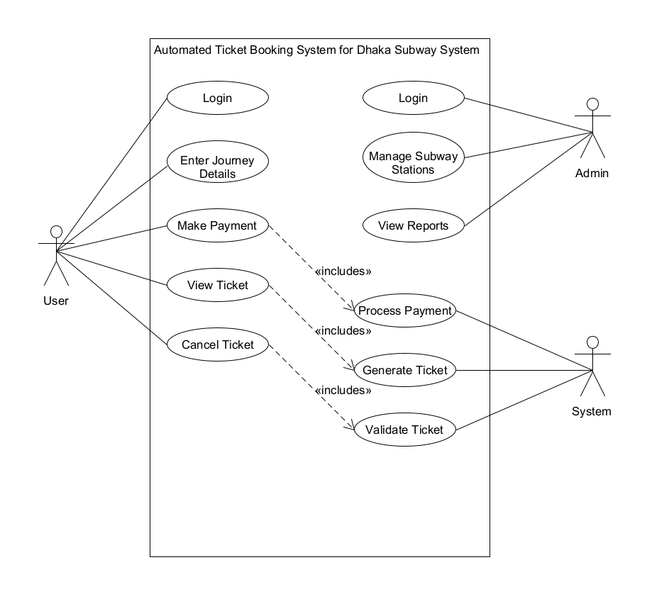

# Stake-holders analysis:

There are many Software Development Life Cycle models, like: waterfall model, prototyping model, spiral model, Incremental model, V- model, agile model. We pick waterfall model for this project because we have clear requirements, functionalities of the system, visibility of stakeholders and we also have enough time schedule for our project.

Groups:

* 1. User of this system.
  2. Company or organizations (providing the subway system automated ticket booking system).
  3. Financing the subway system automated ticket booking system.
  4. Governmental agencies.

# Feasibility study:

The automated ticketing system has the ability to create a ticket by sending an email. It converts each and every mail received into a ticket. So that the user can create a ticket whenever they facing an issue and no need to login to the system for the issues need to be fixed.

Automatic ticket generation, closing duplicate tickets and much more automated process eliminate several human processes makes a faster resolution. Above all, Service Level Agreement can achieve without difficulties. The repetitive tasks are completed by the system. This leads to efficient operation in an organization. Hence it can save a lot of time, which automatically saves money.

# Systems component:

The scope of Dhaka Subway System Automated Ticket booking system is to provide a system that allows an organization to track and manage customer support requests. A ticketing system allows IT support to track, manage, speed up, and deal effectively with incidents. The ticketing software can automatically distribute and assign incidents to the right IT staff member. It can also automatically carry out simple tasks to save time and resources.

Also, there are some components for this system:

1. Ease of use.
2. Ticketing system capability.
3. Knowledge management.
4. Self-service enablement.
5. Cost.

# Process Model:

We are using waterfall model for this project. There are many Software Development Life Cycle models, like: waterfall model, prototyping model, spiral model, Incremental model, V- model, agile model. We pick waterfall model for this project because we have clear requirements, functionalities of the system, visibility of stakeholders and we also have enough time schedule for our project.

There are 6 phases in Software Development Life Cycle.

**Phase 1:** Requirement Analysis and Feasibility study.

**Phase 2:** Design.

**Phase 3:** Coding.

**Phase 4:** Testing.

**Phase 5**: Deployment.

**Phase 6:** Maintenance.

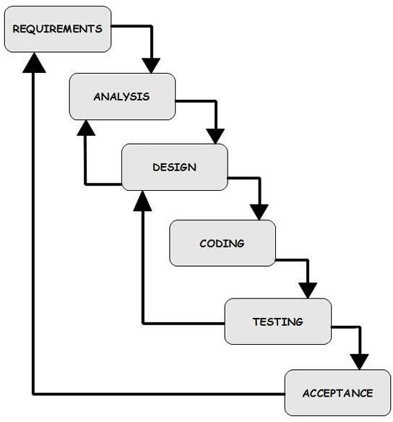

# Efforts estimation:

For calculate effort estimation for this project we are using COCOMO81 (COCOMO81Constructive Cost Model). COCOMO is one of the most widely used software estimation models developed by Barry W. Boehm. COCOMO predicts the effort and schedule for a software product development based on inputs relating to the size of the software and a number of cost drivers that affect productivity.

Equation of COCOMO model is:

effort = c*(size)^k. (Effort is measured in pm(person-months’) 1 pm = 150 units of working hour)

Development time = 2.5*(effort)^t

Required Number of people = effort/Development time There is some constants value base on System type.

COCOMO81 constants

|  |  |  |  |
| --- | --- | --- | --- |
| System Type | c | k | t |
| Organic (2-50 KLOC) | 2.4 | 1.05 | 0.38 |
| Semi-detached (50-300  KLOC) | 3.0 | 1.12 | 0.35 |
| Embedded (more than  300 KLOC) | 3.6 | 1.20 | 0.35 |

|  |  |  |  |  |  |  |  |  |
| --- | --- | --- | --- | --- | --- | --- | --- | --- |
| Project | Design | | Coding | | Testing | | Total | |
| wm | (%) | wm | (%) | wm | (%) | wm | SLOC(source lines of code) |
| DSS Automated  Ticket booking System | 19.0 | (28) | 29.7 | (44) | 19.0 | (28) | 67.7 | 3898 (39 kdsi) |

As our project’s system type is Semi-detached. So, Effort = 3.0*(39)^1.12 = 181.60 pm

Development time = 2.5*(181.60)^0.35 = 15.4 months Required Number of people = 181.60/15.4 = 11.7 (12)

# Activity Network Diagram:

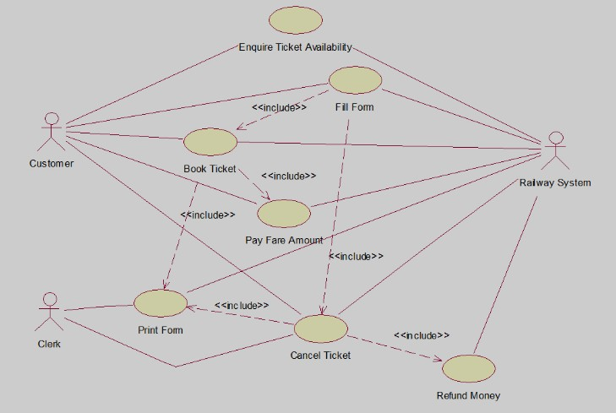

Fig: activity network diagram.

# Risk Analysis:

This mentions a number of possible risks for the project. Also, actions or measures are described to prevent or to reduce the risks.

|  |  |  |  |  |
| --- | --- | --- | --- | --- |
| Risks | Category | Probability | Impact | RMMM |
| Size estimate maybe low | Product Size | 60% | 2 | Discuss with professionals and analysis past similar project  carefully |
| Delivery deadline will be  tightened | Business impact | 50% | 2 | Manage extra working time |
| Staff turnover | Staff size and experience | 60% | 2 | Give more facilities to  staffs |
| Staff  inexperience | Staff size and  experience | 30% | 2 | Train new staff |

## 13.0 Budget for the project

**Cost Analysis:**

### Developer Team:

|  |  |  |  |  |
| --- | --- | --- | --- | --- |
| **Team Member** | **Total Number** | **Hour/Day** | **Monthly Salary (Per Person)** | **Total Salary** |
| Business Analyst | 1 | 6 | 70,000/- | 70,000 |
| Senior Developer | 2 | 6 | 100,000/- | 200,000 |
| UX Designer | 2 | 4 | 60,000/- | 120,000 |

|  |  |  |  |  |
| --- | --- | --- | --- | --- |
| Front-end Developer | 3 | 3 | 70,000/- | 210,000 |
| Back-end Developer | 3 | 3 | 100,000/- | 300,000 |
| Quality Tester | 1 | 5 | 42,000/- | 84,000 |

*Table 1: - Developer Cost Table*

### Office Employees:

|  |  |  |  |
| --- | --- | --- | --- |
| **Team Member** | **Total Number** | **Monthly Salary (Per Person)** | **Total Salary** |
| CEO | 1 | 300,000 | 300,000 |
| Managing Director | 1 | 200,000 | 200,000 |
| General Manager | 1 | 120,000/- | 120,000/- |
| Marketing Manager | 1 | 80,000/- | 80,000/- |
| Accounts Executive | 1 | 80,000/- | 80,000/- |
| Receptionist | 1 | 20,000/- | 20,000/- |

Estimated Monthly Salary for Developers:

90,000 + 200,000 + 120,000 + 210,000 + 300,000 + 168,000 = 1,088,000/-

So, the total salary cost for one month of development is 1,088,000 BDT

The time it will take to finish development is estimated to be around 15 weeks or 3.5 months Estimated Total Salary During Project Development: 1,088,000 X 3.5 = 3,808,000 BDT

Salary cost for office employees per month: 800,000 BDT

Total Salary for office employees (During project development + 1 year of software release): (300,000 + 200,000, 120,000 + 80,000 + 80,000 +20,000) X 15.5 = 12,400,000

So, the total cost of salary during project development is: 3,808,000 + 12,400,000

= 16,208,000

Annual Office Rent and other Cost:

* Office Space Rent:

Approximately 105,000 BDT Per Month [In Banani Area]

Total Office Rent (During project development + 1 year of software release):

= 105,000 X 15.5 = 1,627,500

* Electricity Bills:

Average electricity bill for a typical office space is around 50,000 BDT

So, Total electricity bill (During project development + 1 year of software release)

= 50,000 X 15.5 = 775,000 BDT

* Food:

Monthly Chef cost = 15,000/-

Per day food cost allowance = 250/-

Total food cost during project development: 250 X 19 X 20 X 3.5 = 332,500/- Total food cost for 1 year after software releasing: 250 X 6 X 20 X 12 = 360,000/-

So, the grand total for food (During project development + 1 year of software release):

= 332,500 + 360,000 = 692,500/-

* Others:

Internet Cost (During project development + 1 year of software release): 1000 X 15.5 = 15500/- Approx. office accessories cost 50,000/-

Annual Marketing Cost:

* Advertisement:

Package that includes a total of 30 minutes advertisement 4,10,000/- [5]

* Social Media Sponsored Post:

Facebook/Instagram sponsored post cost per month 25,000/- [6] Sponsored post cost in 1 year = 25,000 X 12 = 300,000/-

* Search Engine Optimization (SEO):

For mid-range companies the cost of SEO per month is 80,000/- [7] For 1 year the cost will be: 80000 X 12 = 960,000/-

Grand Total:

16,208,000 + 1,627,500 + 775,000 + 692,500 + 15,500 +50,000 + 410,000 + 300,000 + 960,000

= 21,038,500 BDT

So, in total the cost is 21,038,500 BDT in one year including software development.

## Conclusion:

In order to reduce the time delay further the usual username password authentication was replaced with a code-based authentication system. The code system is much faster than typing the username and password. Although a smart card system is also applicable in this scenario, considering the cost of a smart card system the code system is highly cost effective. It can also automatically carry out simple tasks to save time and resources.